

Eddie Needs a HOME OF HIS OWN!!!

Eddie is a 2.5 year old, mixed breed. He has a lot of Border Collie Traits and Characteristics https://www.akc.org/dog-breeds/border-collie/
He’s on the smaller side so he will make a great cuddle monster.

Eddie is very friendly, VERY active and social. He does great with other dog but is beginning to struggle in his current environment at Belly Up for Adoptions. He needs a full time parent(s) to really give him what he needs and derserves!!!

He is energetic, happy and loves to live life!! He will need additional training when he arrives in his new home so he can be the best he can be!! Eddie needs a family that is active and understands his needs: he must have an environment that can provide physical exercise PLUS a lot of ENRICHMENT, MENTAL CHALLENEGES and ACTIVITIES to USE THAT BRILLIANT BRAIN OF HIS.

Without BOTH, Eddie will struggle. He is too smart to just play: he would do well with Agility classes, Nose Work, Learning Tricks, more Obedience Training and a family without children under 15 years of age. He really needs attention, activity and enrichment from his Pet Parents to fill his needs. His energy level is too high to be a part of a family with little children. Eventually, perhaps but not right now.

He tends to want things for himself like his food, toys, etc. so the number one thing we’re working on is helping him to learn to share. He is also getting some basic obedience as he learns with us. He does well on our Pack Walks with the Volunteers too!!

He loves to play fetch and will even drop his toy or ball when he returns it to you. He is chipped, neutered, up to date on shots and ready to go to his new home.

Eddie really deserves a place to call his own with Parents that have the time and patience to work with him. ENRICHMENT AND BRAIN WORK are the two things he must have to be the family Member I now he will be.

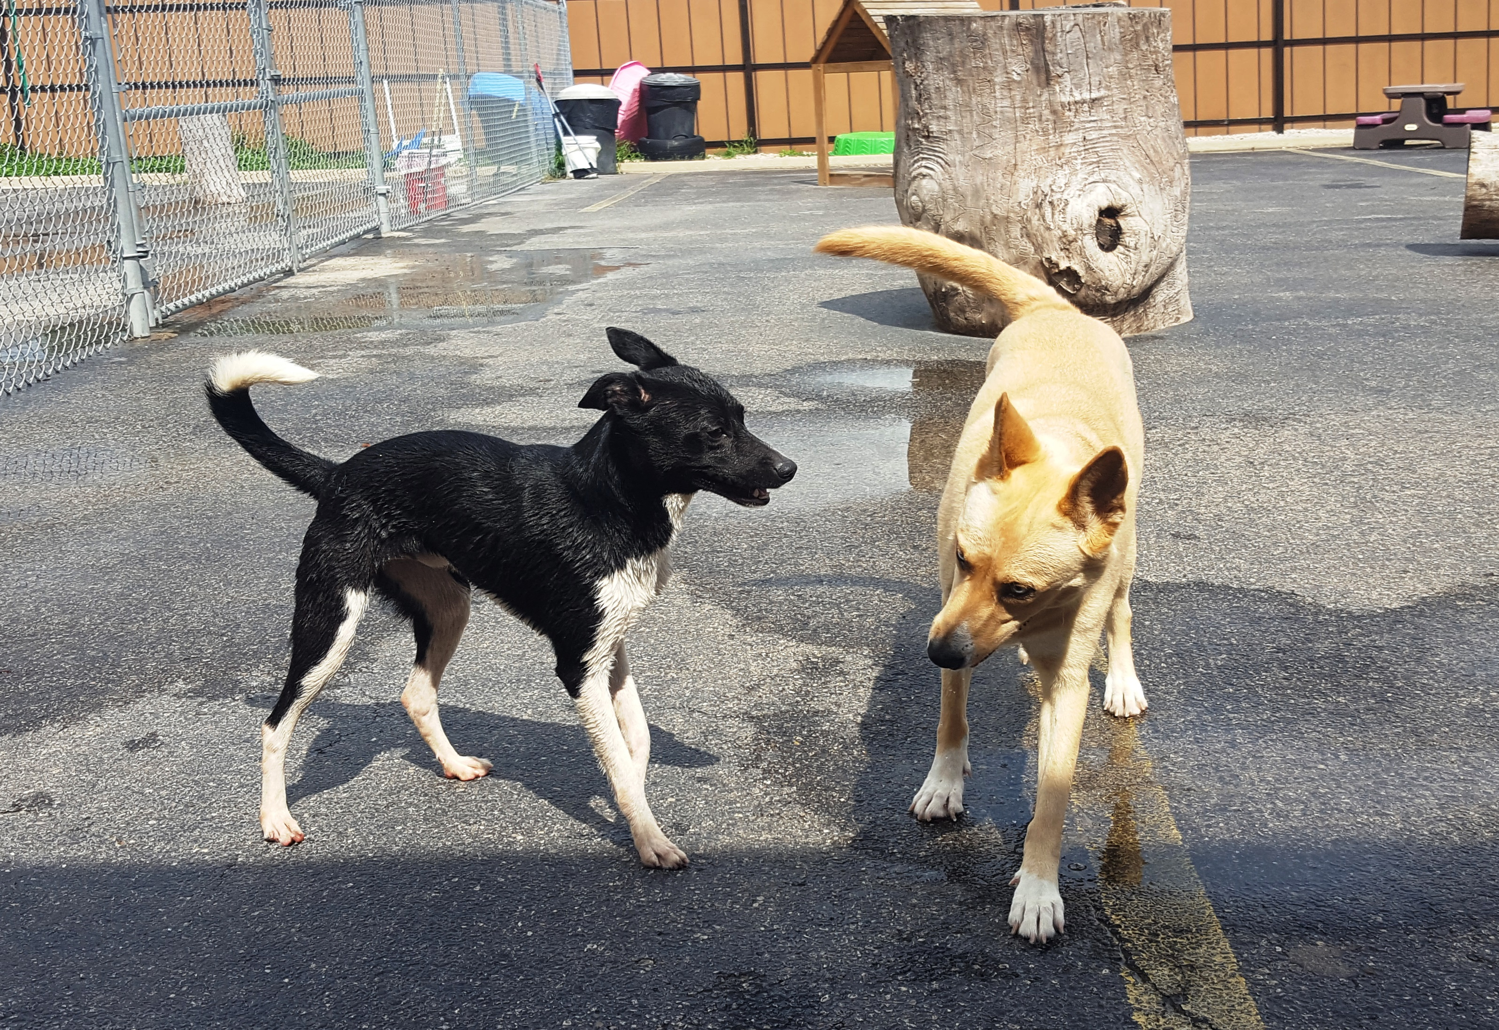
Contact staff@bellyrublub.com to ask for an application. You can also call 630-542-3559 and we’ll send you one!

Eddie is one special dog! He deserves a special place in a new home
ANDd in his parent’s hearts
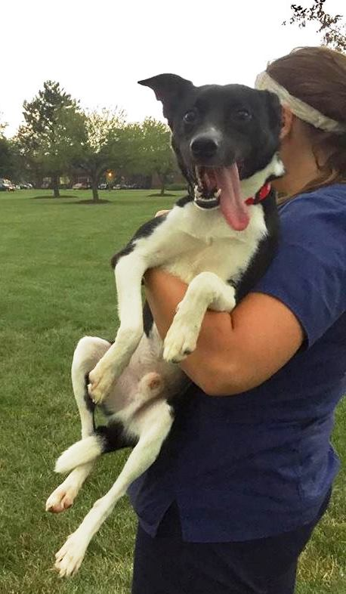

If not you....Who do you know that will be willing and able to give Eddie what he needs! Please ask those you know, talk about him with everyone and feel free to call to set up a time to meet him!!


Just look at that face!!!!

